**Experiment name:**

Clipper and Clamper circuits

**Objectives:**

Study of Clipper and Clamper circuits.

**Apparatus:**

* 1x p-n junction diode - 1N4007
* 1x Resistor - 100KΩ
* 1x Capacitor - 0.1µF
* Signal generator
* DC Power Supply
* Oscilloscope
* Digital Multimeter
* Chords and wire

**Theory:**

**Clipper Circuits:** Clippers are used to remove portions of a signal that exceed a certain voltage level. In the second experiment, a half-wave rectifier, which clips the negative half of the signal, is an example of a clipper. By connecting a diode in series with the load, either the positive or negative half of the signal can be clipped, depending on the diode's orientation.

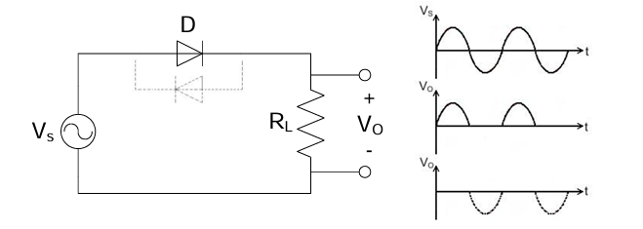

Figure: Simple Diode Clipper circuit

In some cases, a portion of the input signal can be clipped below a specific voltage using a reverse-biased diode. If a battery is introduced with a voltage VVV, the diode will conduct when the input signal exceeds V+0.7V + 0.7V+0.7 volts, passing only signals higher than this threshold to the output.

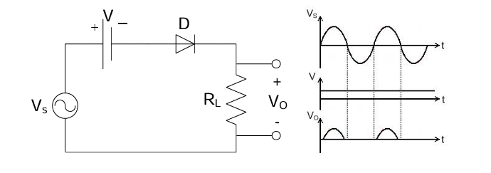

Figure: Clipper Circuit Using Bias Diode

**Parallel Clippers:** A diode is connected in parallel to the load in a parallel clipper. This configuration can clip voltages above 0.7 volts. Using two diodes in opposite directions allows both halves of the signal to be limited to 0.7 volts.

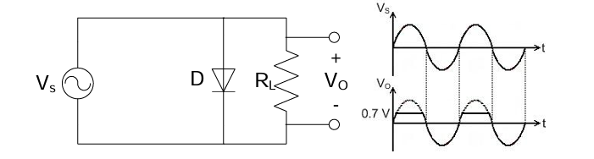

Figure: Parallel Clipper Circuit

Biasing the diode in parallel allows you to set a specific clipping level. By connecting a battery in series with the diode, you can clip the signal at a chosen voltage level for one or both half cycles.

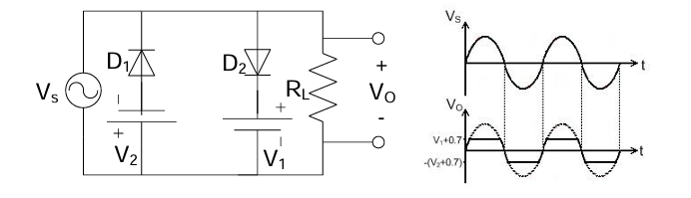

Figure: Biased Parallel Clipper Circuit

**Clampers:** Clamper circuits shift the input signal by adding a DC voltage. For instance, if a signal varies between -10 and +10 volts, a positive clamping circuit can adjust the signal to range from 0 to 20 volts. Similarly, a negative clamping circuit would shift the signal between -20 and 0 volts.

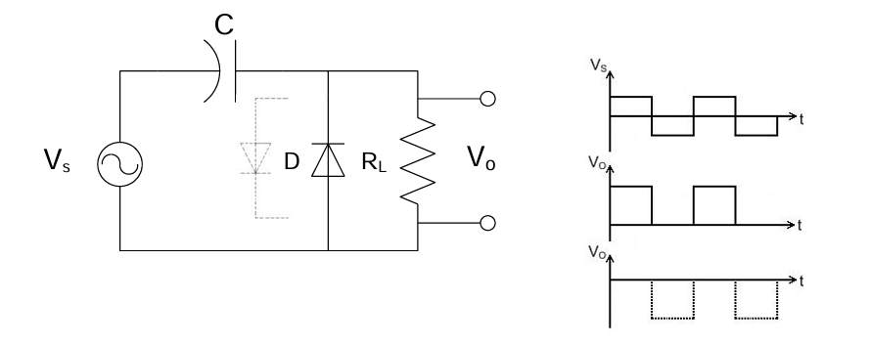

Figure: Clamper Circuit

**Circuit Diagram:**

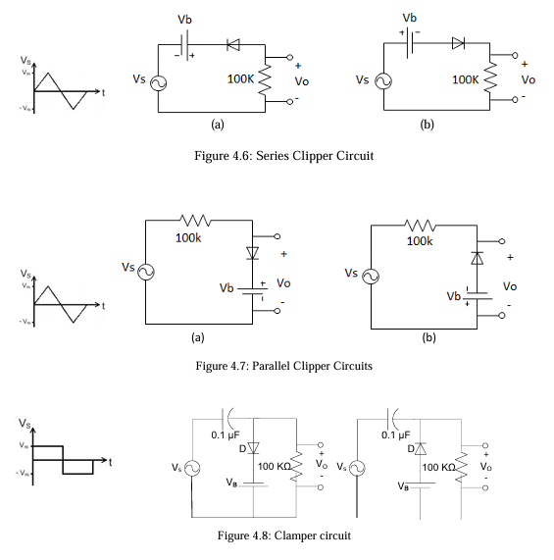

**Experimental Procedure:**

• We connected the biased series clipper circuit as shown in figure 4.6, using a sinusoidal voltage source with a peak of 5V (10Vp-p) and a frequency of 1kHz from a signal generator.

• We set the bias voltage (Vb) to 2.5V and used an oscilloscope to observe and draw both the input voltage (Vs) and the output voltage (Vo) on the same graph paper.

• We decreased Vb from 2.5V to 0V and observed the corresponding output waveforms.

• We increased Vb from 2.5V to 5V and again observed the changes in the output waveforms.

• We repeated the above steps for the biased parallel clipper circuit (figure 4.7), using a triangular voltage source with the same specifications (5V peak, 1kHz).

• We constructed the clamper circuit using a 0.1 µF capacitor and repeated the steps using a rectangular and square voltage source, each with a peak of 5V and 1kHz frequency (figure 4.8).

• For the clamper circuit at Vb = 2.5V, we recorded the maximum (Vmax) and minimum (Vmin) values of the output waveforms.

**Experimental Data Table:**

**Results:**

In this experiment, the input-output waveforms for clipper and clamper circuits were examined on an oscilloscope to determine how they affect signal levels. Adjusting the bias voltage V(b) in the clipper circuits (Figures 4.6 and 4.7) resulted in modifications to the clipped sections of the signal. At a bias of 2.5V, the waveform clipped the signal at specified thresholds set by the diode orientation and bias voltage, essentially deleting either the positive or negative component of the waveform. Increasing V(b) to 5V increased the clipping range, further reducing the output waveform amplitude, whilst decreasing V(b) lowered the clipping range, allowing more of the waveform to pass.

In the clamper circuit (Figure 4.8), adding a DC level pushed the whole waveform upward without altering its shape. At V(b)=2.5V, the output waveform moved positive, resulting in new maximum and minimum amplitudes. These results show the clipper's ability to selectively remove portions of signal and the clamper's ability to change signal levels.

**Questions and Answers:**

**1. Using values from your data table, for all the circuit diagrams, plot the input-output**

**waveforms observed on the oscilloscope for Vb = 2.5V.**

**Ans.**

The input-output waveforms observed on the oscilloscope for Vb = 2.5V are given below:

Series Clipper Circuits

Input-Output Waveform of Fig 4.6(a) Input-Output Waveform of Fig 4.6(b)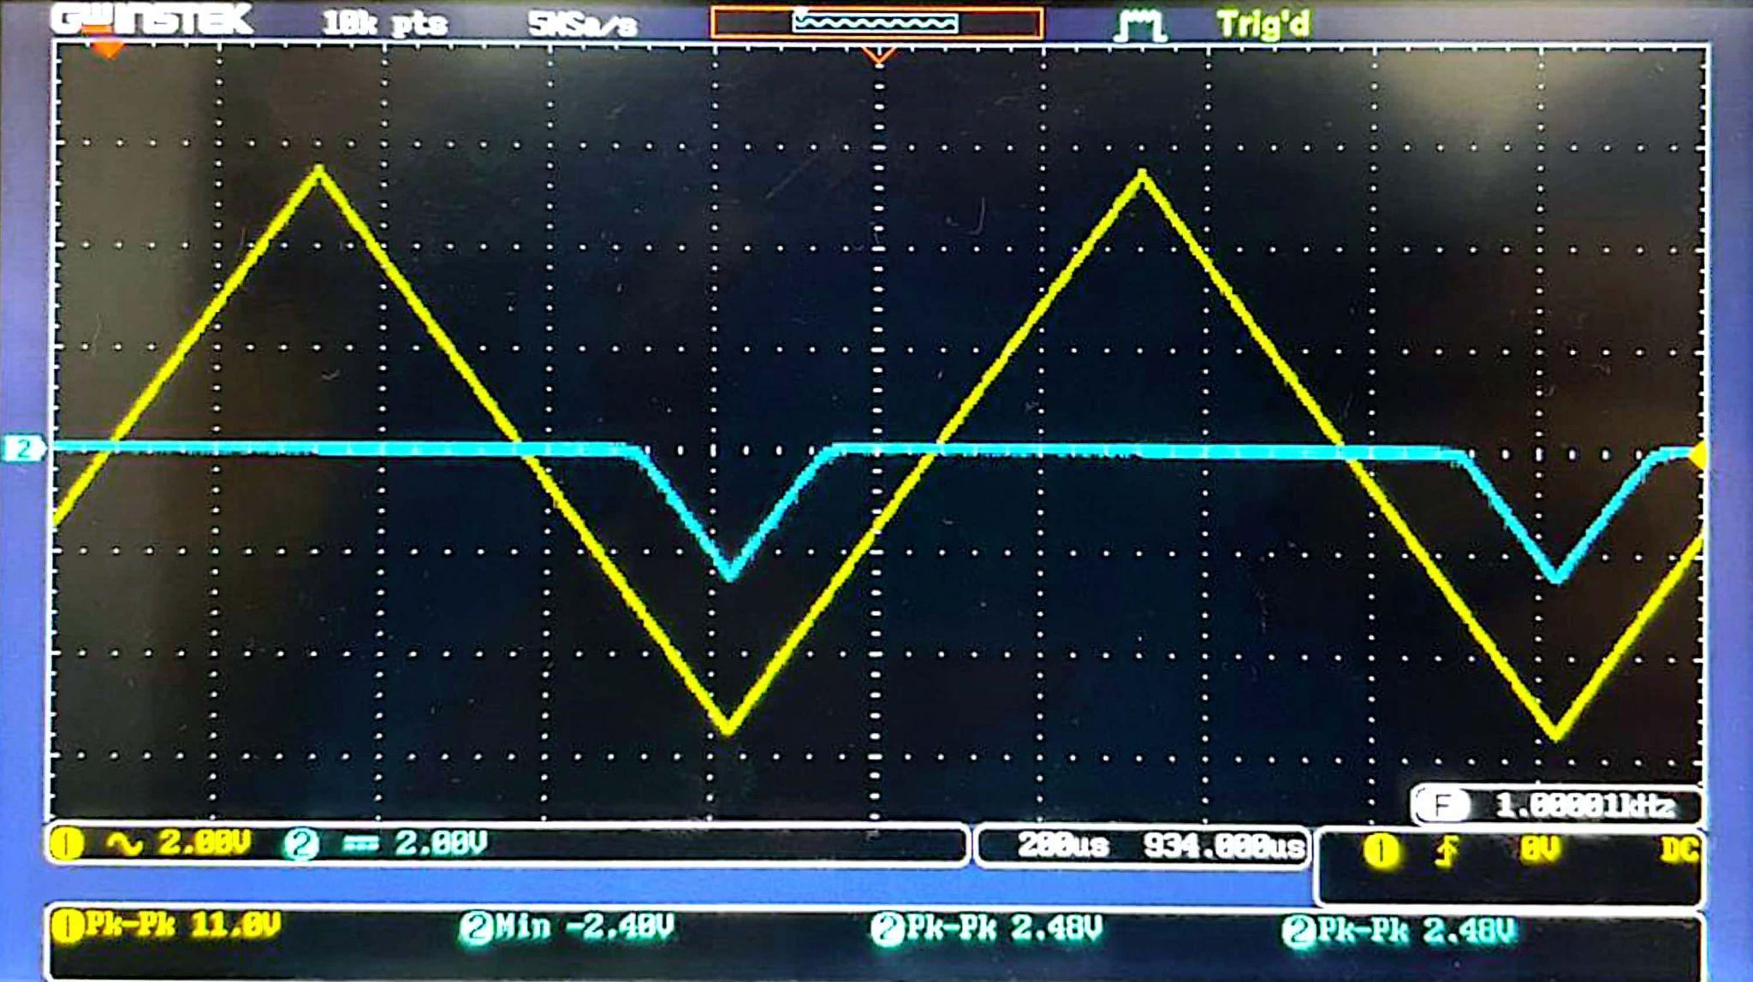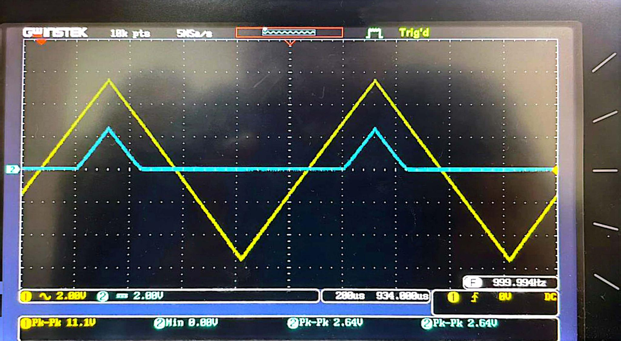

Parallel Clipper Circuits

Input-Output Waveform of Fig 4.7(a) Input-Output Waveform of Fig 4.7(b)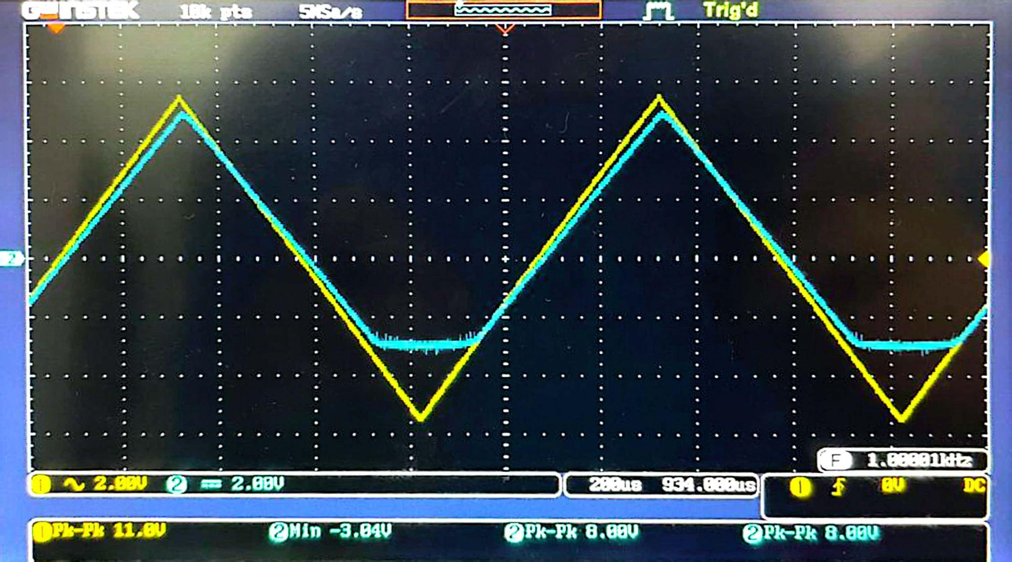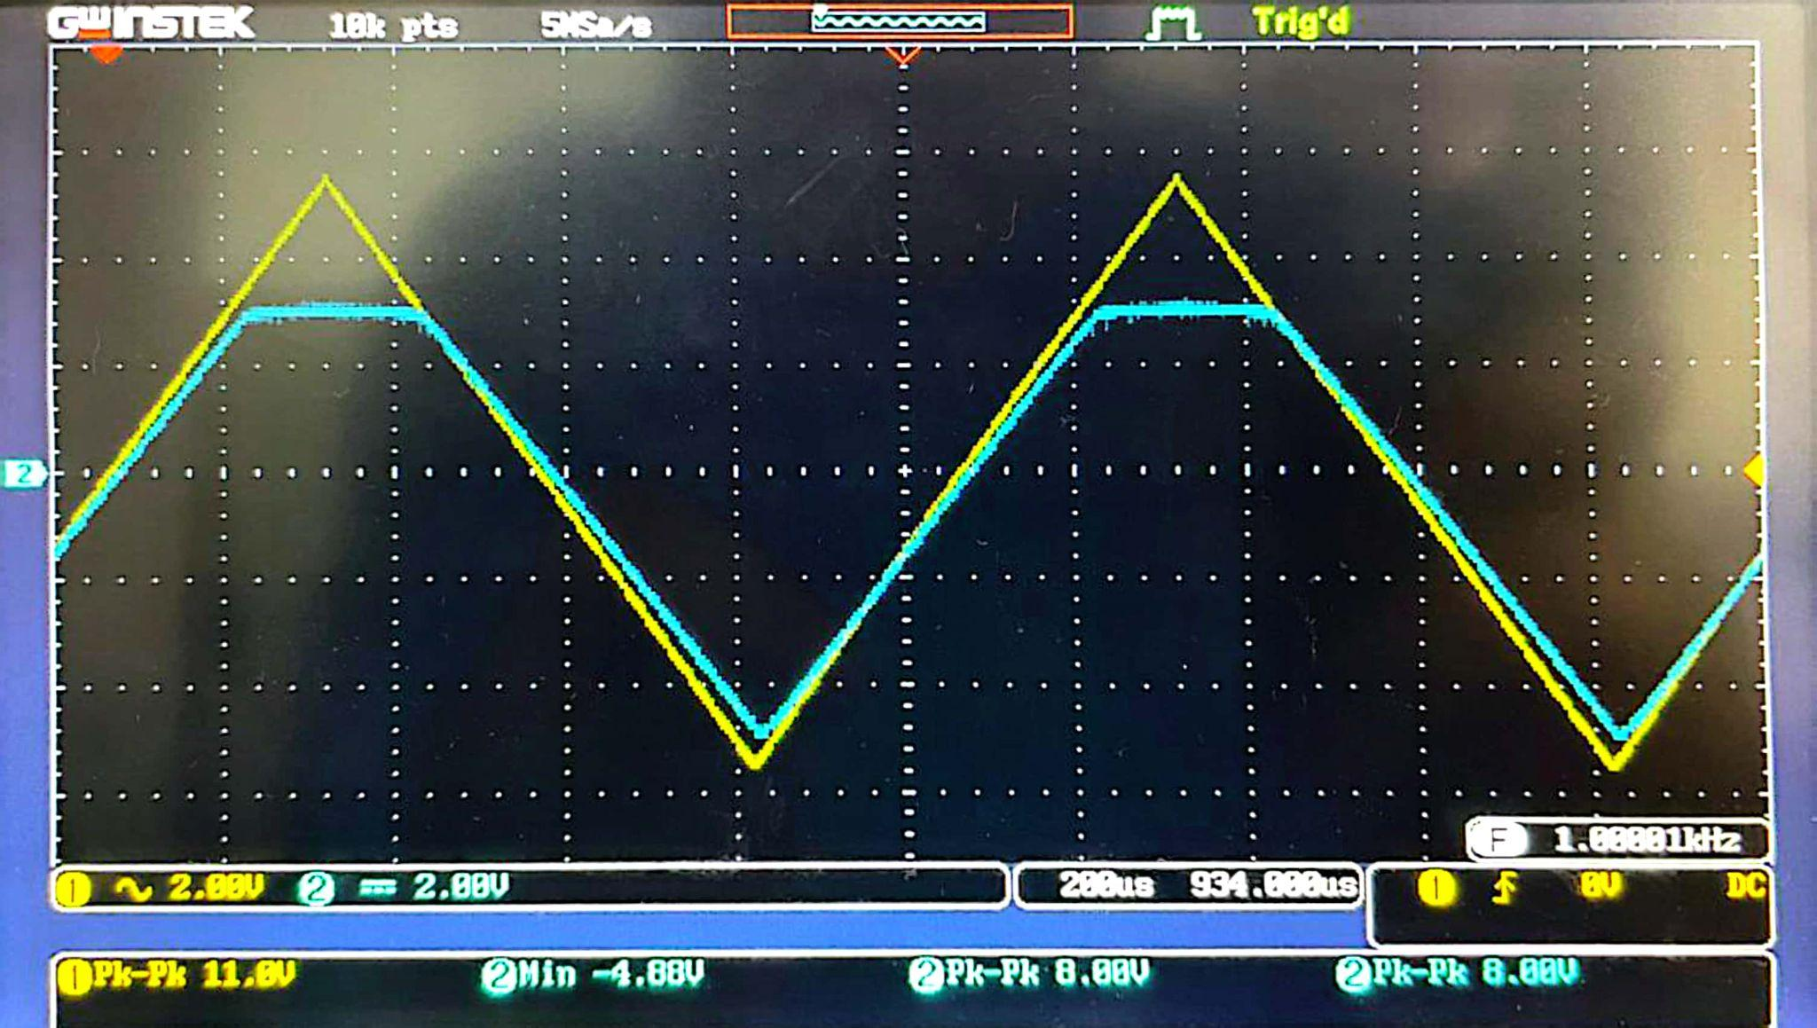

Clamper Circuits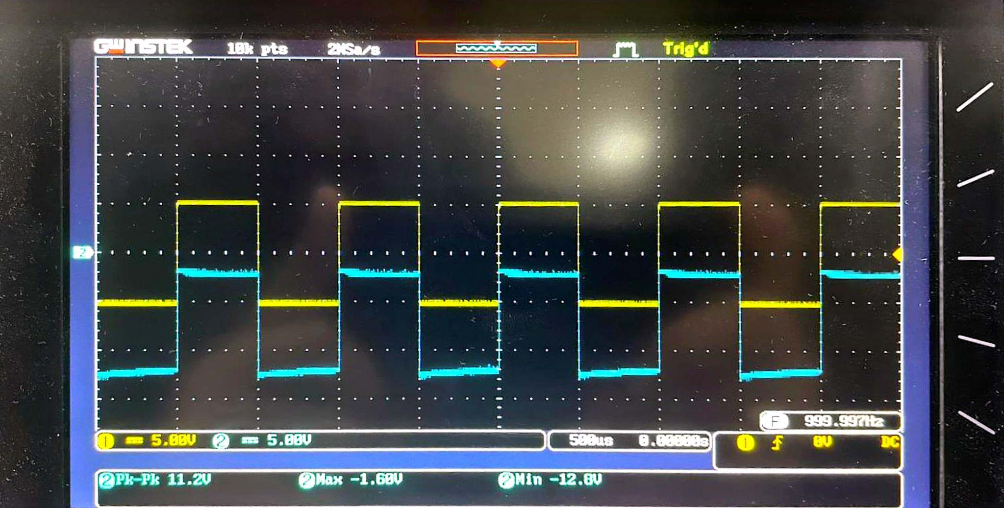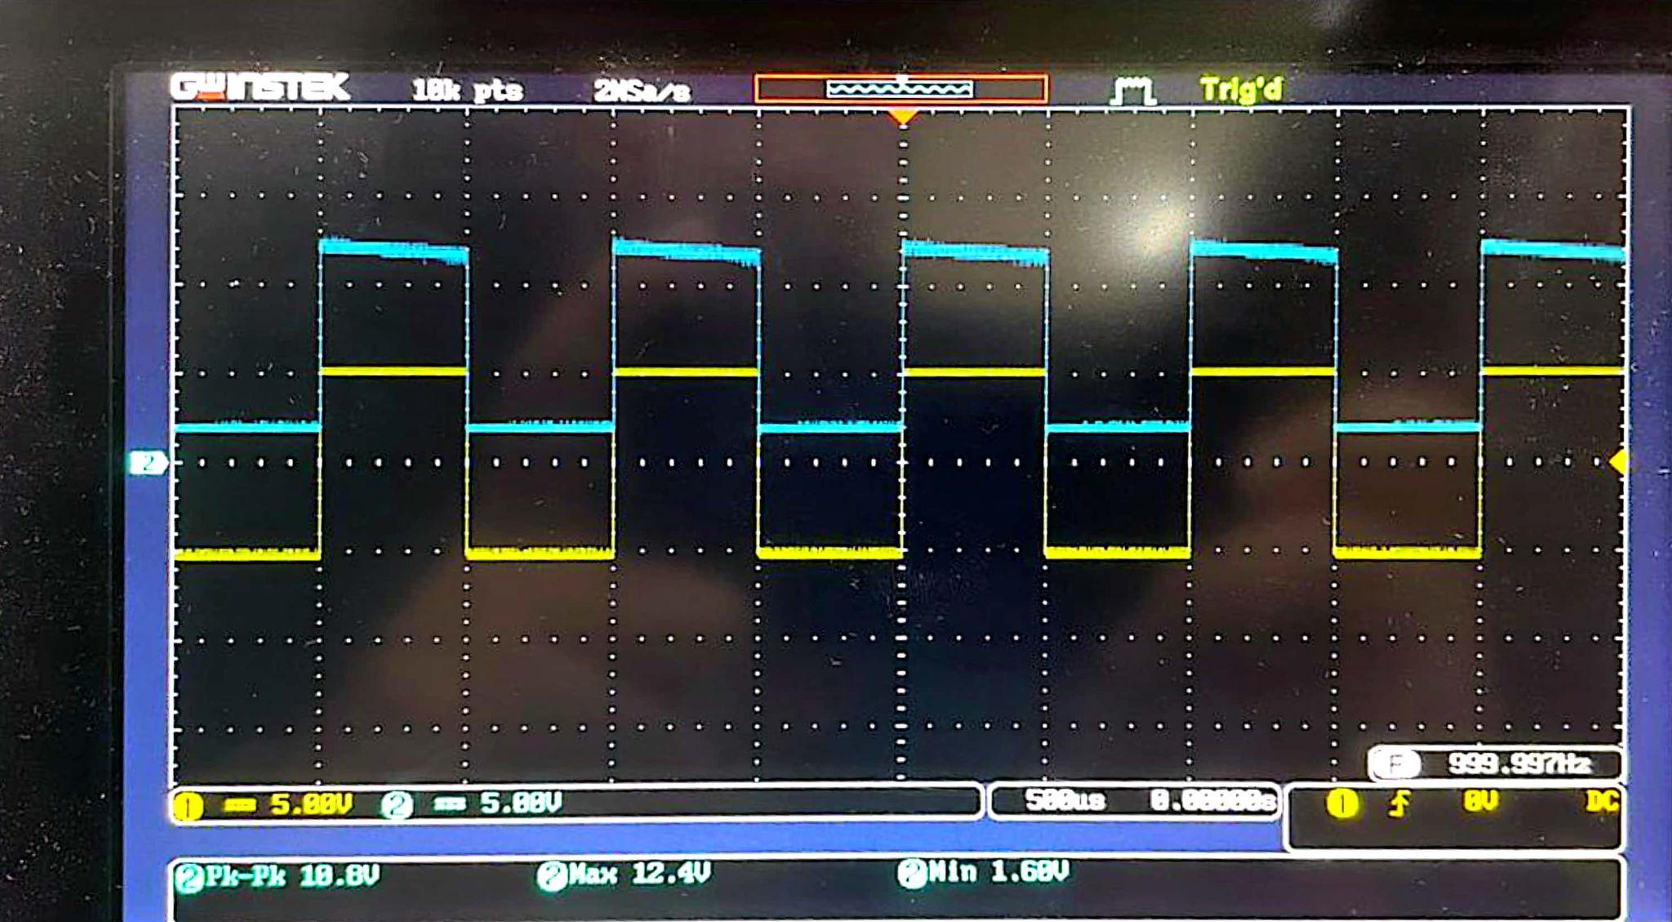

Input-Output Waveform of Fig 4.8(a) Input-Output Waveform of Fig 4.8(b)

**2. For Fig 4.6(a &b), Fig4.7 (a & b) and Fig 4.8 (a & b) what change did you observe in the output voltage, In procedure-4? Explain the reason behind such a change.**

**Ans.**

Figure 4.6 (a & b) shows that when V = 2.5, the Vo(p-p) was 2.48V for (a) and 2.64V for (b) positive peaks above 2.5V are clipped. As the voltage was reduced from 2.5V to 0V, Vo(p-p) went up to 5.12V for (a) and 5.20V for (b) at 0V, Lowering V decreases the clipping threshold, allowing more of the waveform to pass. When V = 0, the input signal voltage is less than the diode's threshold (0.7V for a silicon diode) thus, the diode remains reverse-biased and does not conduct. This voltage is close to the input voltage, 5 V(p-p), because the diode does not clip the input signal.

Figure 4.7 (a & b) shows that when Vb = 2.5, the Vo(p-p) was 8.00V in both (a) and (b), Positive peaks are clipped. As the voltage reduced from 2.5V to 0V clipping reduces, the Vo(p-p) reduced to 5.60V for (a) and 5.44V for (b) at 0V. On Figure 4.7(a), The diode clips the positive half-cycles. The output waveform will have the positive half-cycles clipped at roughly 0.7V, while the negative half-cycles will remain unchanged. In Figure 4.7(b), the diode clips the negative half-cycle while allowing the positive half-cycles to flow through unchanged. When the clipping voltage is 0V, the diode clips the waveform just above its threshold voltage, resulting in a flattened region at the waveform's peak.

Figure 4.8 (a & b) shows that, When Vb = 0V in Fig. 4.8(a), the diode behaves as a forward bias and all current passes through it. The capacitor gets completely charged. As a result, the output voltage nears 0V. Diode behaves as reverse bias during the negative half cycle, and all current passes through the resistor. Thus, the output voltage is capped when the voltage -Vm is added to the capacitor's stored voltage. In Fig. 4.8(b), the exact opposite takes place. In that situation, on the negative half cycle, the diode behaves as a forward bias.

**3. For Fig 4.6(a &b), Fig4.7 (a & b) and Fig 4.8 (a & b) what change did you observe in**

**the output voltage, In procedure-5? Explain the reason behind such a change.**

**Ans.**

In 4.6(a) With V=5V, the output waveform is clipped at 5V, allowing only peaks below this threshold to pass. As V increases, the positive waveform becomes absent. In 4.6(b) Negative peaks are clipped below -5V as V increases, leaving just a tiny portion of the negative waveform at the output.

In 4.7(a) At V=5V, the positive output waveform is clipped, keeping the peaks at this level and displaying only the lower regions of the waveform.

In 4.7(b) Negative clipping occurs at -5V, which restricts the negative waveform as V increases.

In 4.8(a) As V increases to 5V, the waveform shifts upward, keeping all positive peaks above the baseline. In 4.8(b) With V=5V, the waveform drops downward, and all negative peaks appear further below the baseline.

**Discussion:**

In the lab experiment with clipper and clamper circuits, we showed the necessary concepts of waveform shaping and signal processing. The clipper circuit successfully controlled the voltage levels of the input signal, removing distortion, but the clamper circuit changed the waveform's DC level without affecting its shape. Learning how these circuits may be used in electrical devices to control signal amplitudes was a significant outcome. However, we encountered difficulties such as component tolerance issues, which sometimes resulted in unexpected output voltages. To fix this, we recalibrated our circuit setups and took exact measurements using multimeters, which gave us better precision in our results. Overall, this experiment helped us improve our practical abilities in circuit design and analysis.

**Simulation:**

